Team Violet: Final Wireframe and Navigation Diagram Artifacts
Course: CSC 3220 Applications Programming

Wireframe UI: https://www.figma.com/design/5w79Pxb6dEJJjo69qlwpvT/MarketSimulator?node-id=0-1&p=f
Navigation Diagram URL: https://drive.google.com/file/d/1tpzPSZJE19yO822cvK3KHLGb7NzA3epo/view?usp=share_link
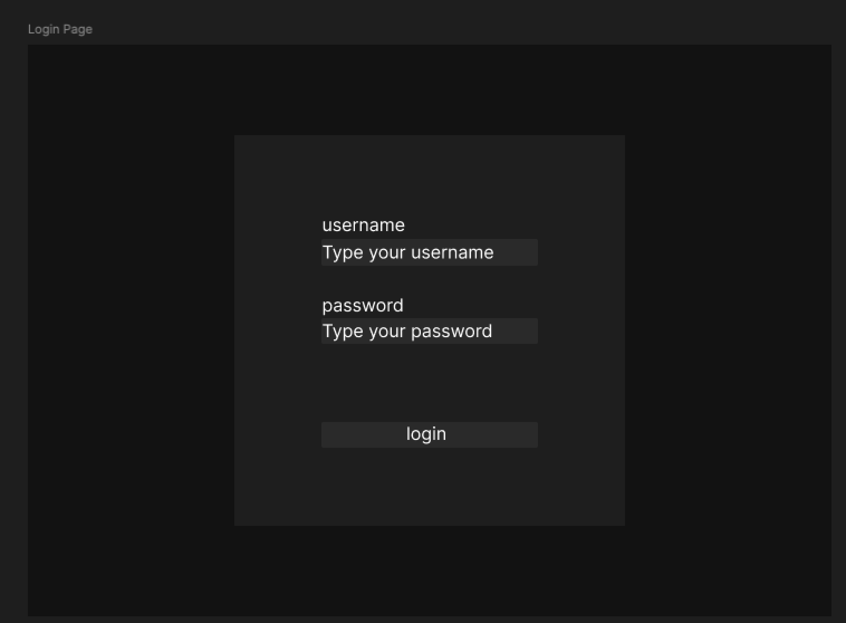
Figure 1: Login Page. This is a Non-Modal screen acting as the primary entry point for existing users.

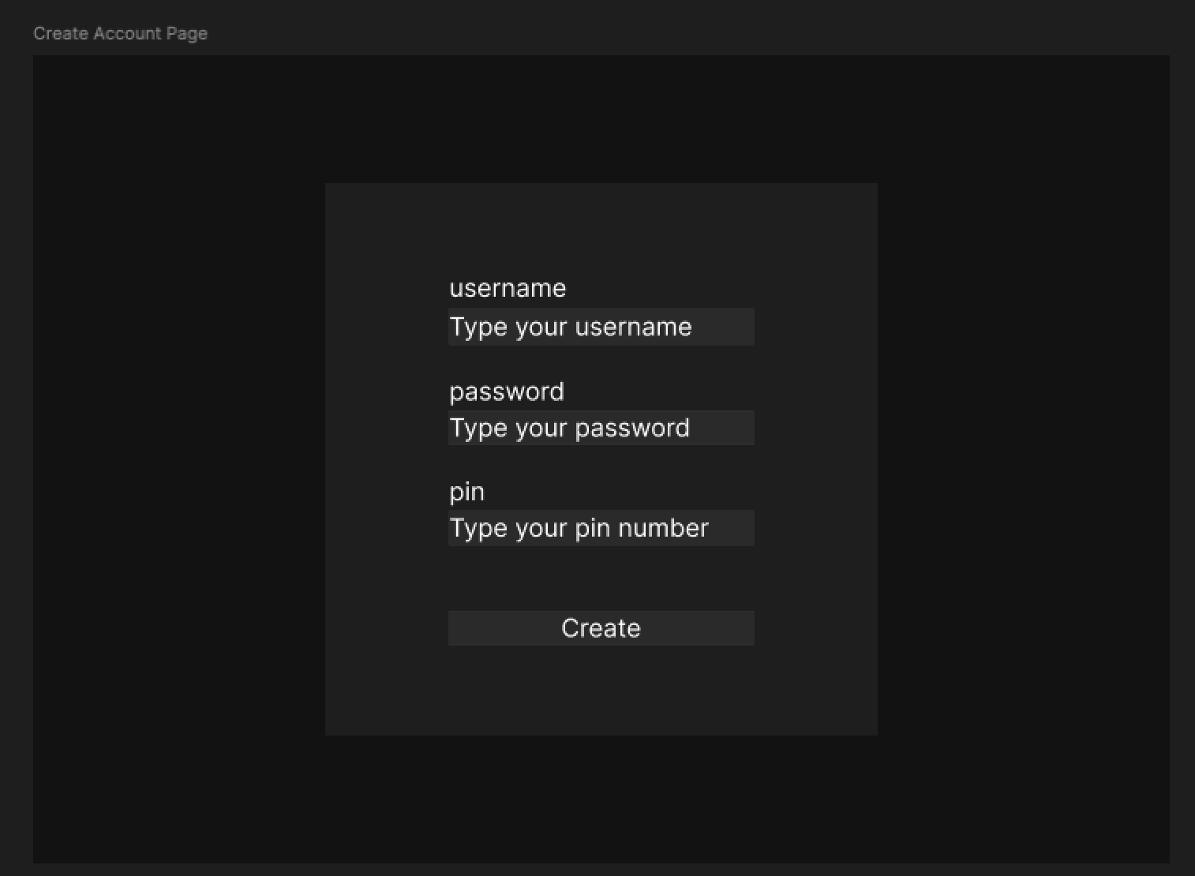
Figure 2: Create Account Page. This is a Non-Modal screen for new user registration, featuring an added security PIN requirement.
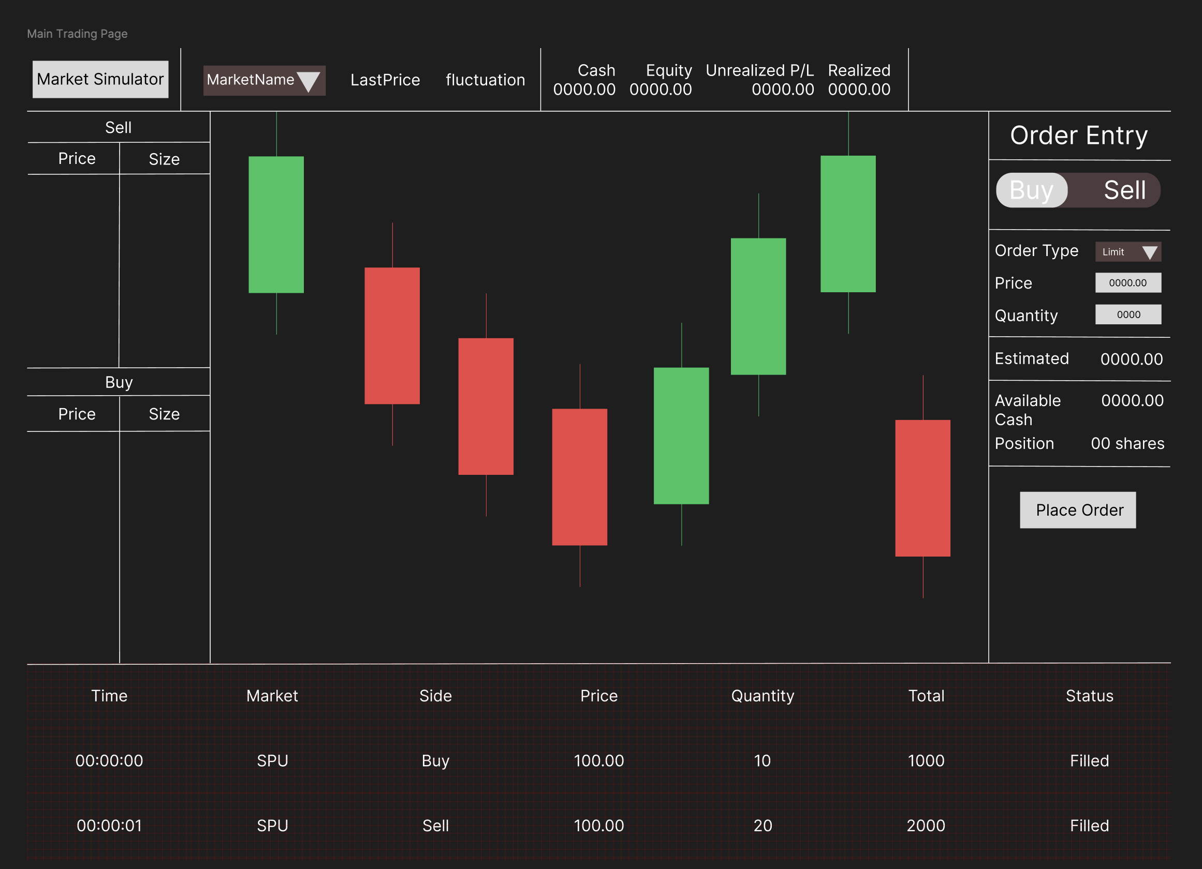
Figure 3: Main Trading Dashboard. This is a Non-Modal window containing the real-time order book, candlestick chart, and primary Order Entry controls.
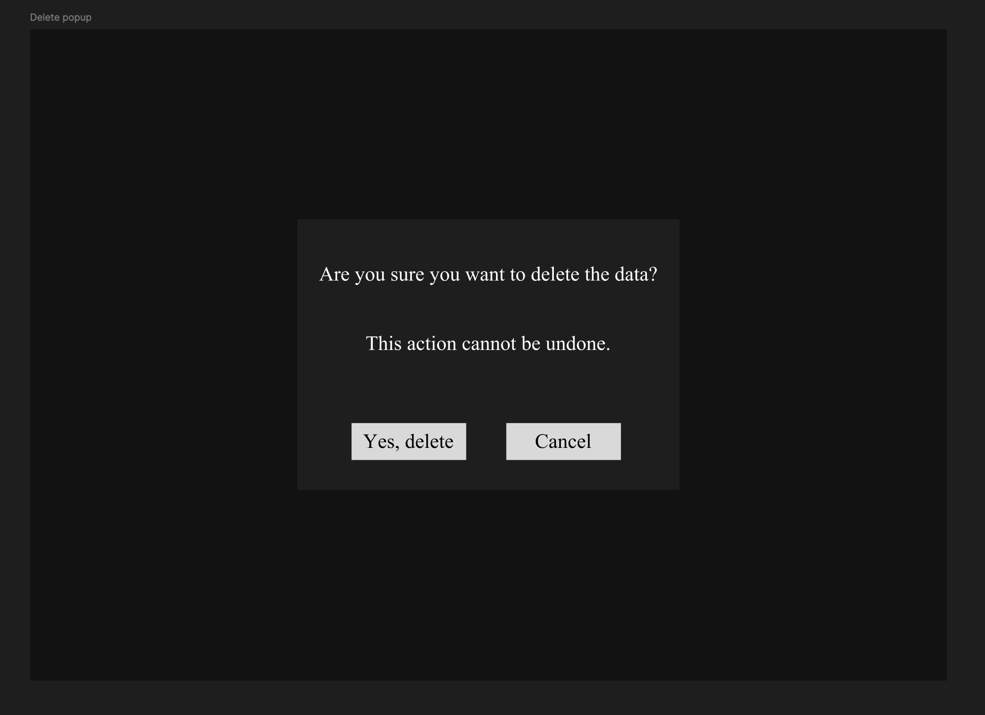
Figure 4: Menu and Delete Confirmation. The menu is Non-Modal, but it triggers a strict Modal dialog box asking for deletion confirmation to prevent accidental data loss.
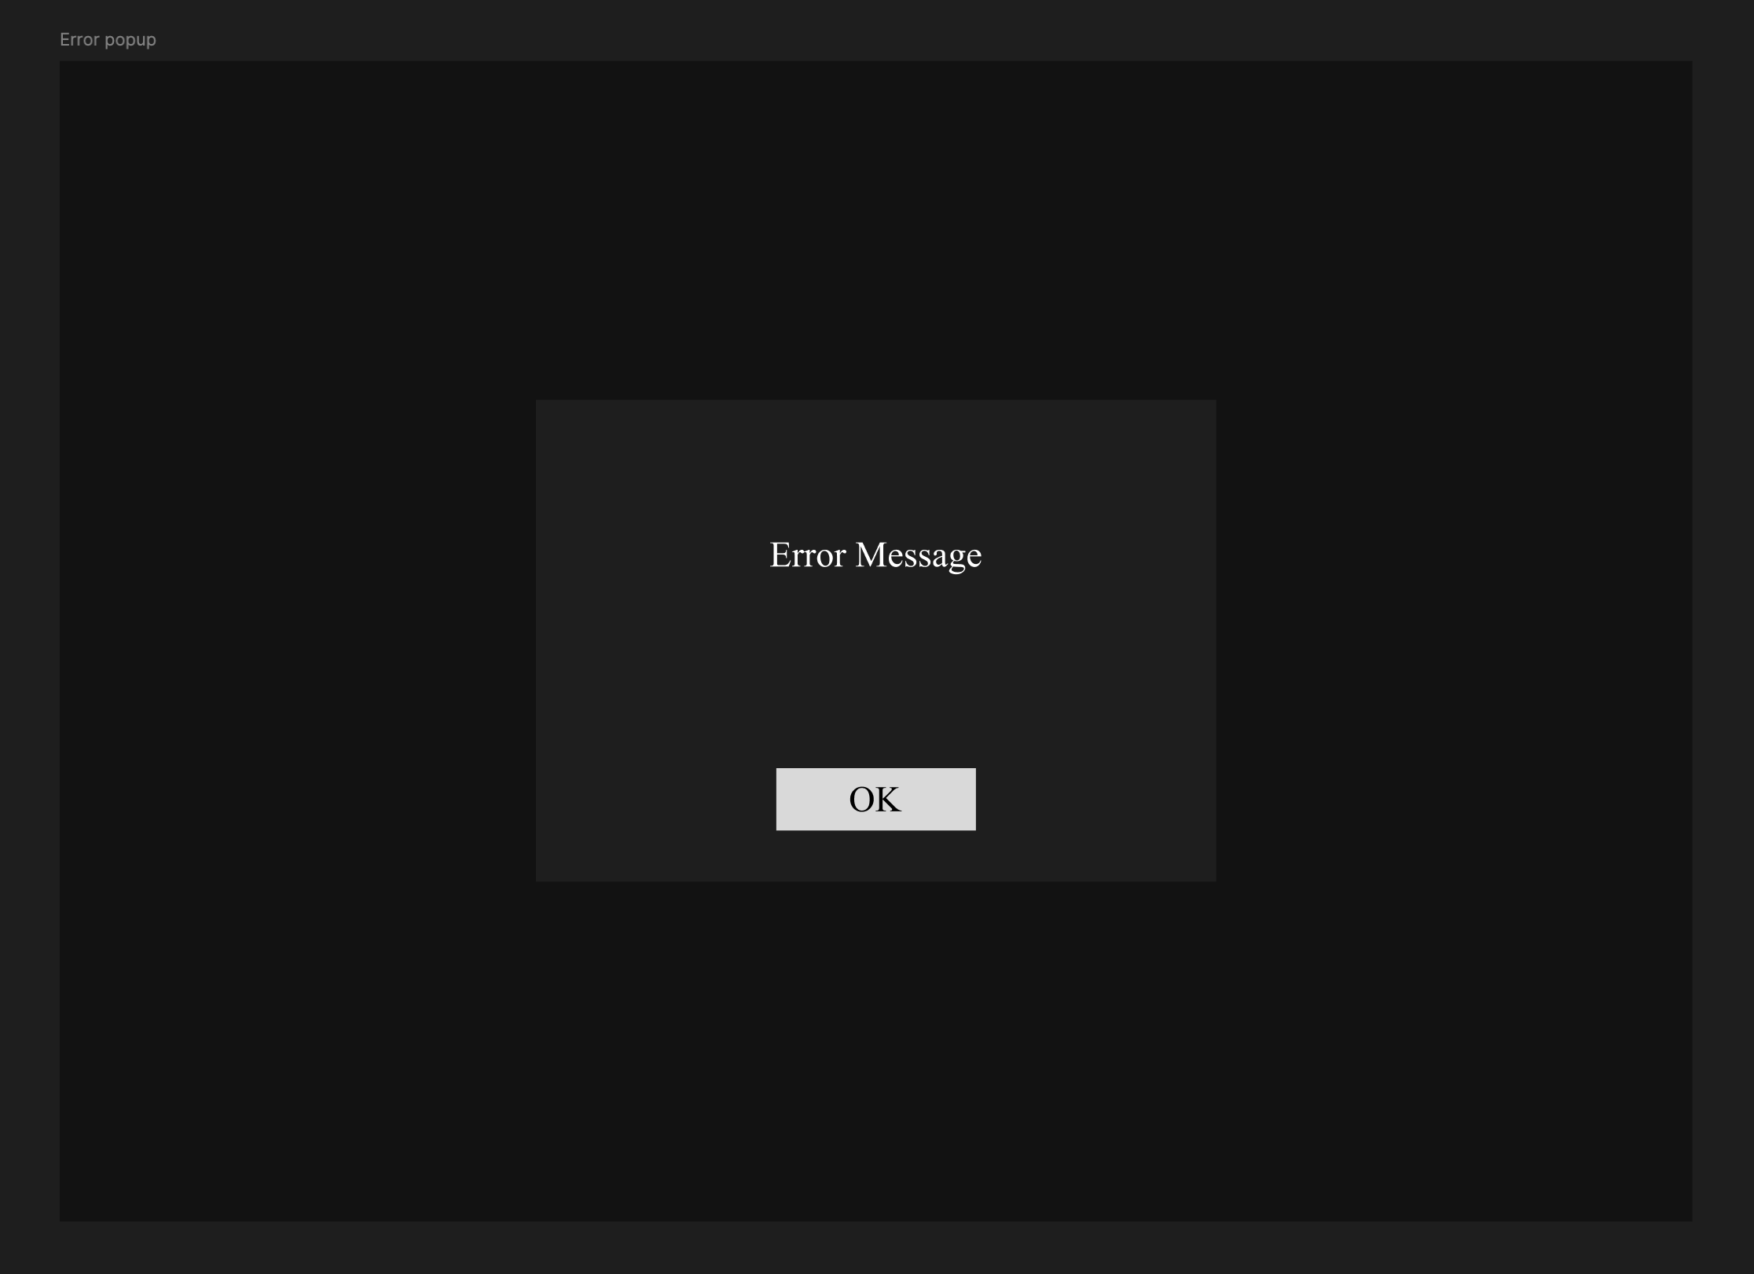
Figure 5: Error Popup. This is a strict Modal dialog box that intercepts invalid user input during order entry and forces acknowledgement.

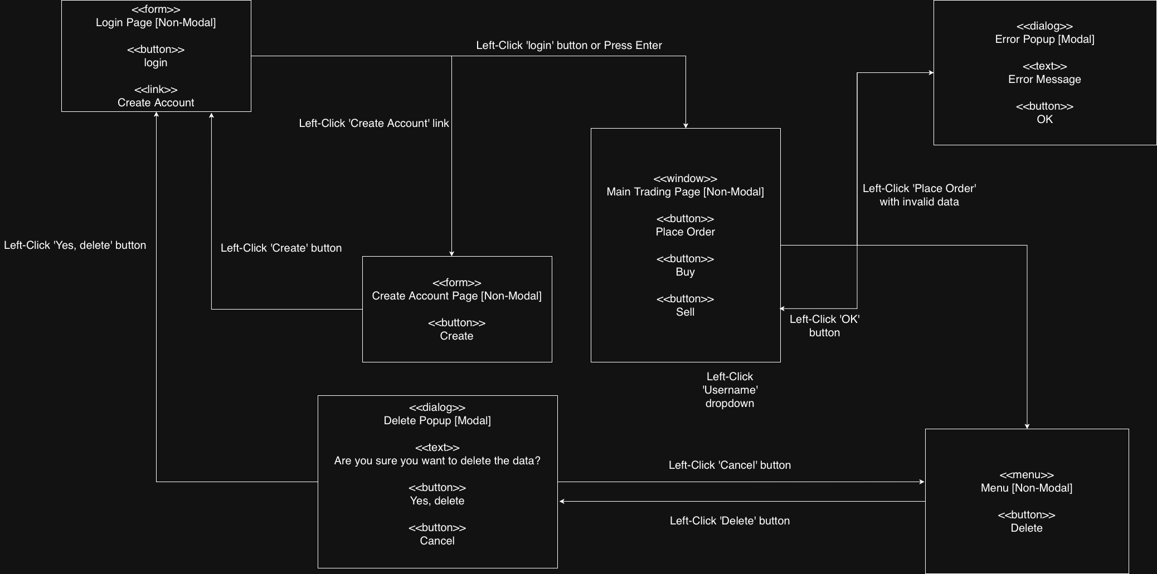
Figure 6: Final Window Navigation Diagram. This diagram maps all UI screens, details specific user actions (e.g., clicks/keystrokes) for traversal, and explicitly defines the modality of all components.

